# Arduino UNO R4 Wi-Fi HA sensors data logger

## Project Goal:

To prevent data loss, a card reader module is connected to the data collection Arduino, and a TF card is inserted. By writing code, a data logger is created to record the data on the TF card. So, let's see how to implement this project.

### Difficult Level: C:\Users\52pidev1\Documents\Tencent Files\49719976\FileRecv\星星3.jpg

## Preparations:

### Hardware Preparations:

* 1 x Arduino UNO R4 Wi-Fi board
* 1 x Temperature & humidity sensor
* 2 x USB-C programming cable
* 1 x TF card (32GB)
* 1 x TF card reader module
* 1 x 52Pi experiment platform [Optional]
* 10 x Male to Female Jumper wire

### Software Preparation

* Arduino IDE
* Libraries: ArduinoMqttClient, DHT11, SD

Do remember install SD library from library manager.

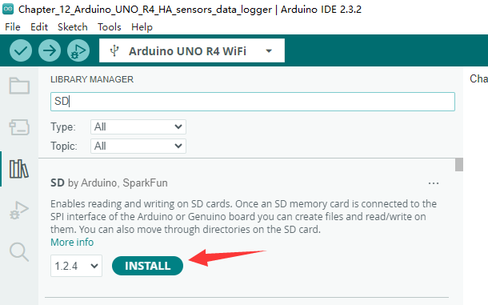

* Home Assistant

### Wiring diagram:

#### Temperature & humidity sensor

|  |  |
| --- | --- |
| Arduino UNO R4 Wi-Fi board | DHT11 |
| 5V | VCC |
| GND | GND |
| D7 | DATA |

#### TF card reader module

|  |  |
| --- | --- |
| Arduino UNO R4 Wi-Fi Board | TF card reader module |
| 3.3V | 3.3V |
| GND | GND |
| D10 (CS） | CS |
| D11 (COPI) | MOSI |
| D13 (SCK) | CLK |
| D12 (CIPO) | MISO |

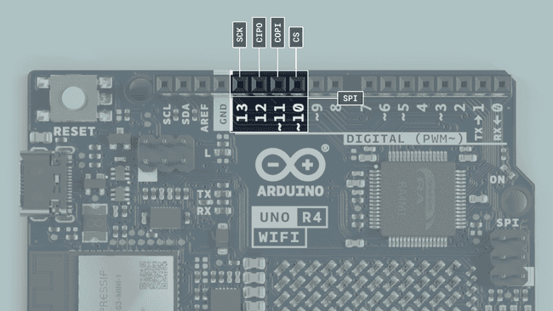

### Demo code:

#include <ArduinoMqttClient.h>

#include <WiFiS3.h>

#include <DHT11.h>

#include <SD.h>

#include <SPI.h>

#include "arduino_secrets.h"

///////please enter your sensitive data in the Secret tab/arduino_secrets.h

char ssid[] = SECRET_SSID;  // your network SSID (name)

char pass[] = SECRET_PASS;  // your network password (use for WPA, or use as key for WEP)

/*

The circuit:

   DHT11 sensors on digital pin 7

   SD card attached to SPI bus as follows:

 ** MOSI - pin 11

 ** MISO - pin 12

 ** CLK - pin 13

 ** CS - pin 10

*/

#define DHT11PIN 7

DHT11 dht11(DHT11PIN);

const int chipSelect = 10;   // pin 10 to CS pin

WiFiClient wifiClient;

MqttClient mqttClient(wifiClient);

const char broker[] = "192.168.3.109";

int port = 1883;

const char topic1[] = "can/temperature";

const char topic2[] = "can/humidity";

void setup() {

  pinMode(DHT11PIN, INPUT);

  Serial.begin(9600);

  while (!Serial) {

    ;

  }

  Serial.print("Attempting to connect to WPA SSID: ");

  Serial.println(ssid);

  while (WiFi.begin(ssid, pass) != WL_CONNECTED) {

    Serial.print(".");

    delay(1000);

  }

  Serial.print("IP address:");

  Serial.println(WiFi.localIP());

  Serial.println("You're connected to the network");

  Serial.println();

  mqttClient.setId("uno_R4_01");

  mqttClient.setUsernamePassword("jacky", "mypassword");

  Serial.print("Attempting to connect to the MQTT broker: ");

  Serial.println(broker);

  if (!mqttClient.connect(broker, port)) {

    Serial.print("MQTT connection failed! Error code = ");

    Serial.println(mqttClient.connectError());

    while (1) {

      if (!mqttClient.connect(broker, port)) {

        Serial.print("MQTT connection failed! Error code = ");

        Serial.println(mqttClient.connectError());

      };

      delay(1000);

    }

  }

  Serial.println("You're connected to the MQTT broker!");

  Serial.println();

  Serial.print("Initializing SD card...");

  if (!SD.begin(chipSelect)) {

    Serial.println("Card failed, or not present");

     while (1);

  }

  Serial.println("card initialized.");

}

void loop() {

  mqttClient.poll();

  delay(1000);

  float temperature = dht11.readTemperature();

  float humidity = dht11.readHumidity();

  Serial.print("Temp: ");

  Serial.print(temperature);

  Serial.print("\t humidity: ");

  Serial.println(humidity);

  File dataFile = SD.open("datalog.txt", FILE_WRITE);

  if (dataFile) {

    Serial.println("data logger begin...");

    dataFile.print(temperature);

    dataFile.print(",");

    dataFile.println(humidity);

    dataFile.close();

    Serial.println("data logger end...");

    } else {

    Serial.println("error opening datalog.txt");

  }

  mqttClient.beginMessage(topic1);

  mqttClient.print(temperature);

  mqttClient.endMessage();

  mqttClient.beginMessage(topic2);

  mqttClient.print(humidity);

  mqttClient.endMessage();

}

#### Code Explanations:

Define header files

#include <ArduinoMqttClient.h>

#include <WiFiS3.h>

#include <DHT11.h>

#include <SD.h>

#include <SPI.h>

#include "arduino_secrets.h"

* Define variables to connect Wi-Fi

char ssid[] = SECRET_SSID;  // your network SSID (name)

char pass[] = SECRET_PASS;  // your network password

* Define DHT11 sensor’s data pin and create an object.

#define DHT11PIN 7

DHT11 dht11(DHT11PIN);

* Define CS Pin for SPI bus.

const int chipSelect = 10;   // pin 10 - CS pin

* Define MQTT protocol’s information

WiFiClient wifiClient;

MqttClient mqttClient(wifiClient);

const char broker[] = "192.168.3.109";

int port = 1883;

const char topic1[] = "can/temperature";

const char topic2[] = "can/humidity";

* Initializing TF card

 Serial.print("Initializing SD card...");

  if (!SD.begin(chipSelect)) {

    Serial.println("Card failed, or not present");

    while (1);

  }

  Serial.println("card initialized.");

* Read data from sensor

 // read data from dht11

  float temperature = dht11.readTemperature();

  float humidity = dht11.readHumidity();

* Open a file called “datalog.txt” and write the data into this file, after writing, save and close the file.

  File dataFile = SD.open("datalog.txt", FILE_WRITE);

  if (dataFile) {

    Serial.println("data logger begin...");

    dataFile.print(temperature);

    dataFile.print(",");

    dataFile.println(humidity);

    dataFile.close();

    Serial.println("data logger end...");

  }

  else {

    Serial.println("error opening datalog.txt");

  }

### Check Data

Collect data for a period of time, then disconnect the power supply of arduino, then unplug the TF card, insert it into a USB card reader and into the computer, open the datalog.txt file in the TF card through the resource manager to see the data information.

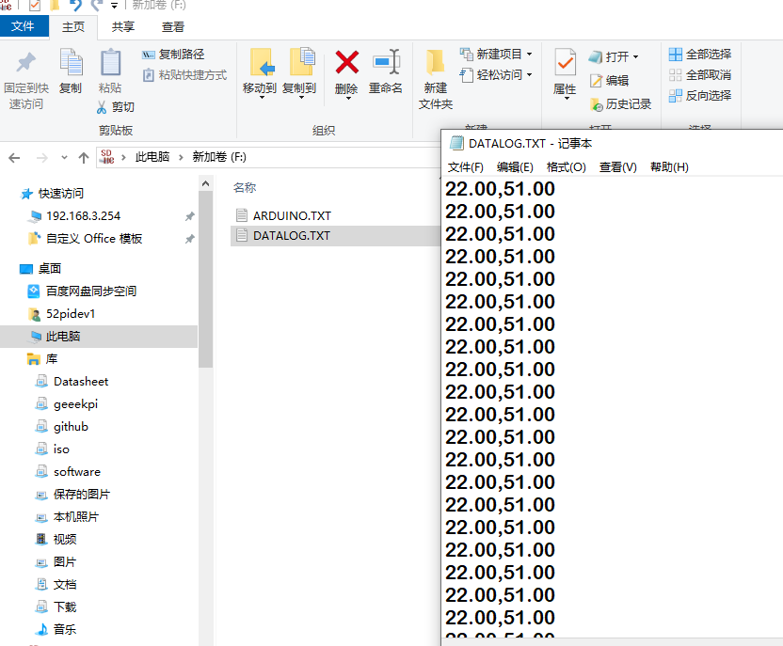

### Check Data on Home Assistant

Because we continue to use the topic from the previous chapter, we do not need to change the configuration file and we can also see the data display information. Of course, if you want to customize it better, please refer to Chapter 11 to re-write the sensor part of the configuration file and restart the home assistant.

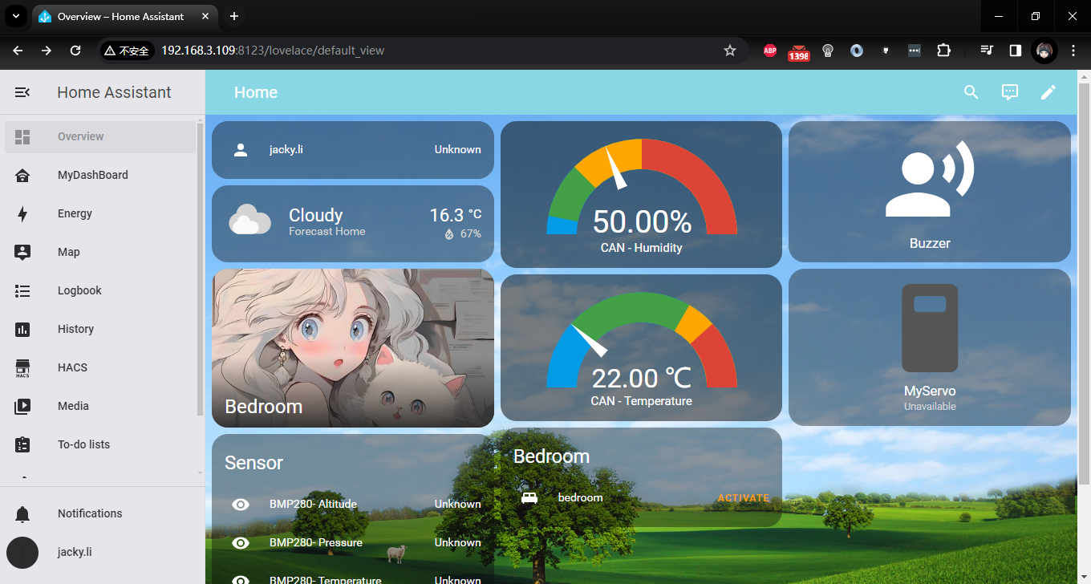

For example: adding a new dashboard

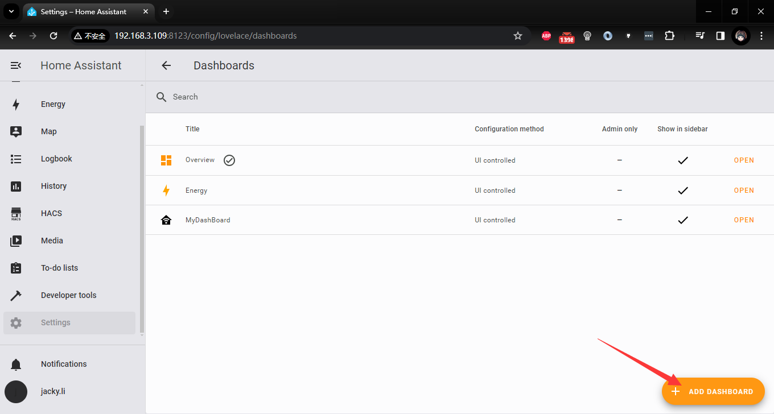

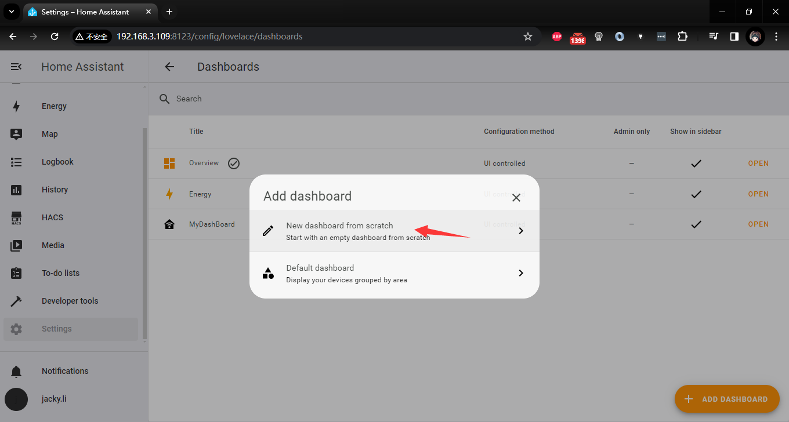

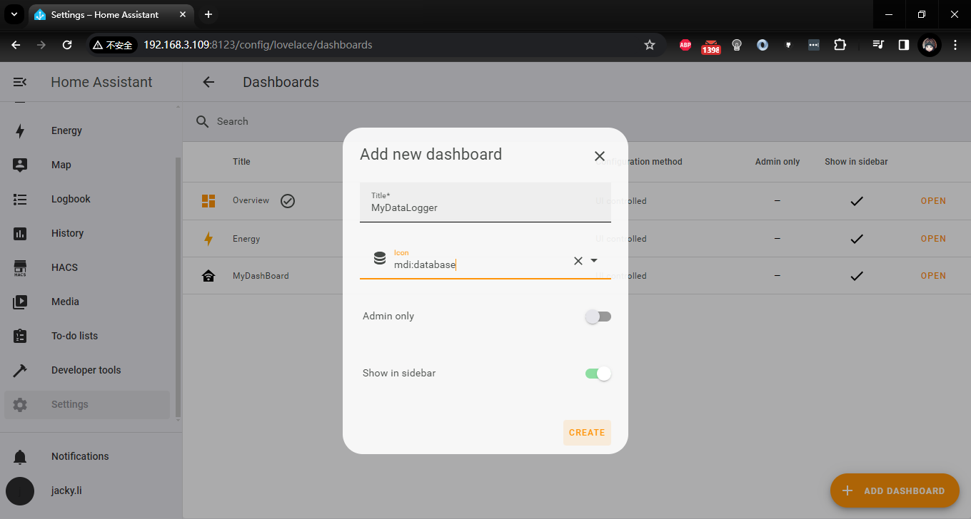

adding new cards

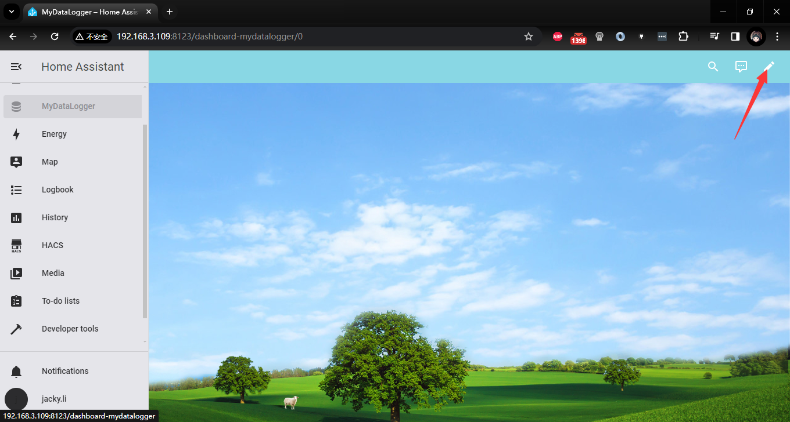

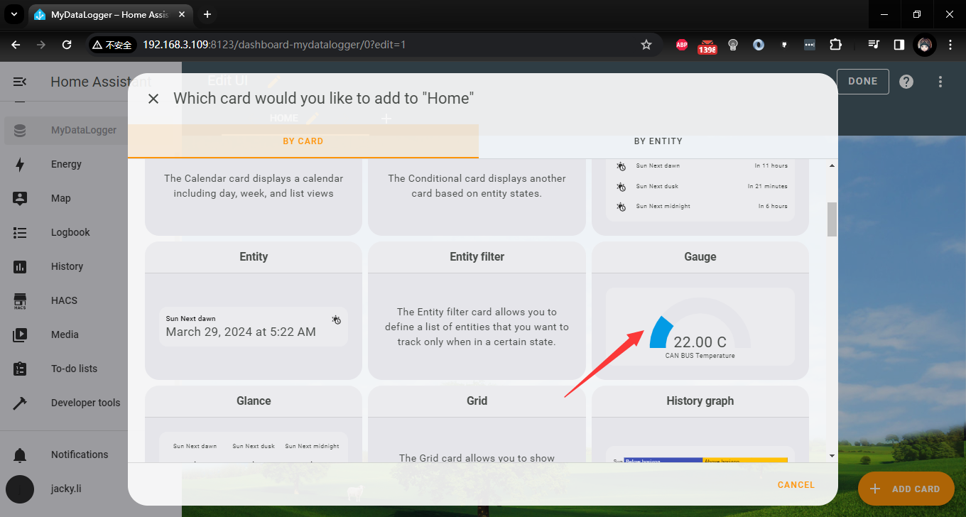

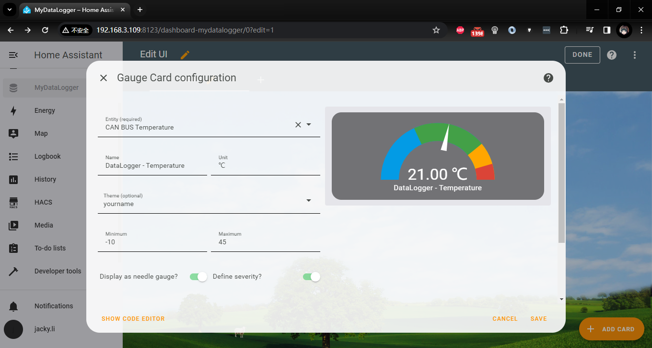

Duplicate and edit it to humidity data

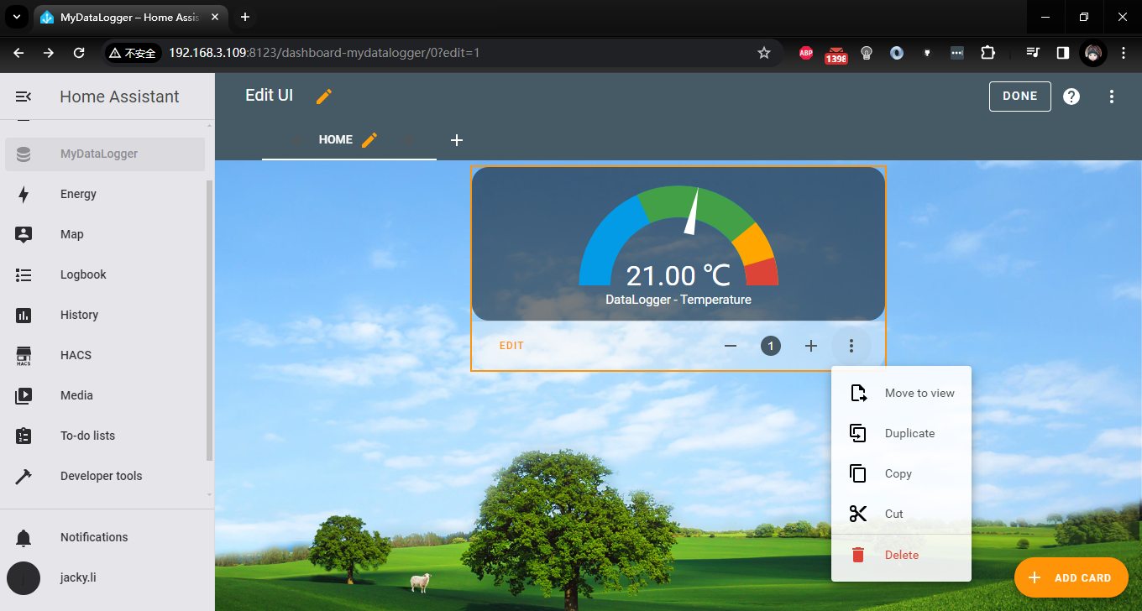

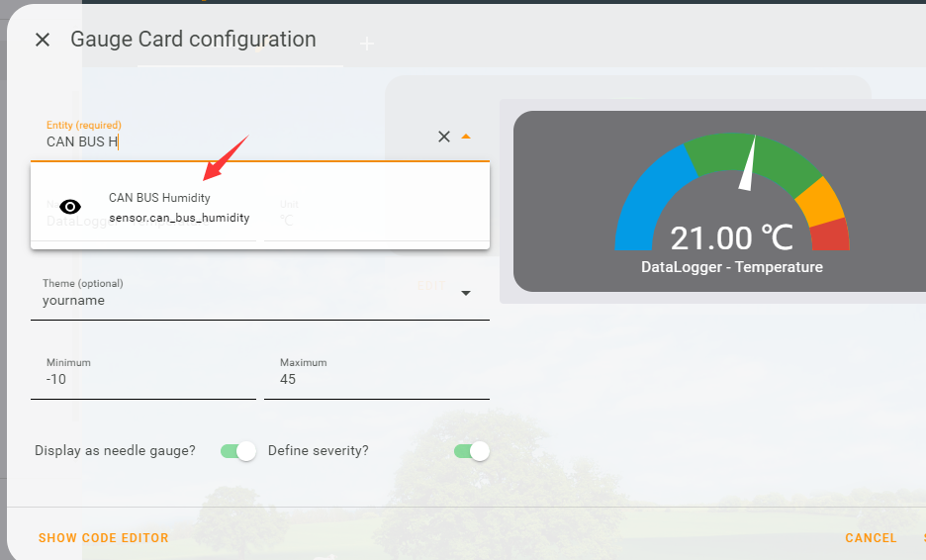

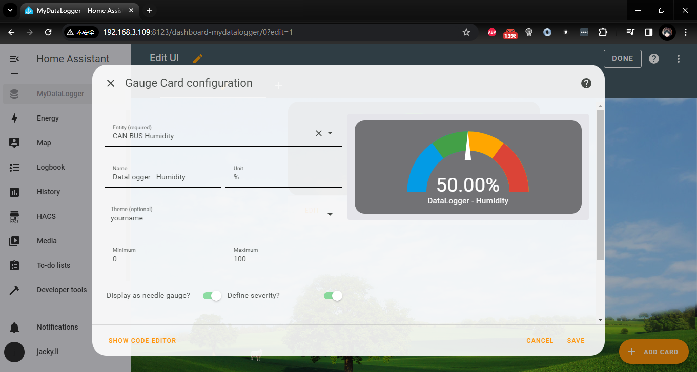

Click “DONE”!

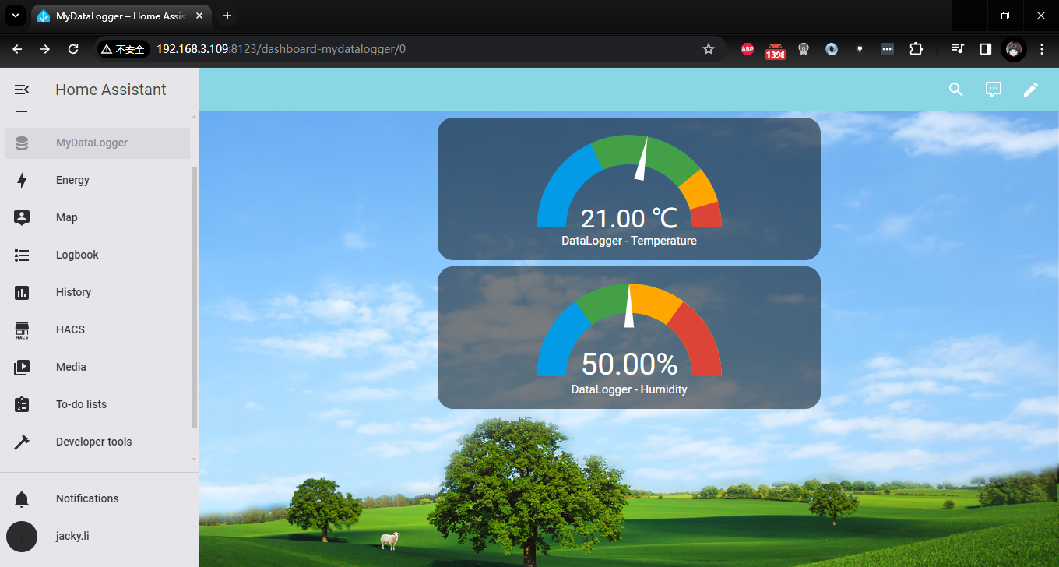

You have already got new data logger information and also have a backup on TF card!!!